Street Light Standards

Public Street Light Fixture Design Options - 2026

Type of Light | Cost
Standard Street Light | No Cost
Standard Decorative Street Light | Incremental cost for a decorative fixture. For 2026, the incremental cost is $3,000 per light.  Costs may be petitioned/assessed
Non-Standard Decorative Street Light | Full cost to development  Cannot be petitioned/assessed  Payment required prior to installation  Actual cost plus 2 additional poles and fixtures per development for inventory and replacement needs. Actual cost will depend on pole and fixture selected by Developer.

Standard Street Light
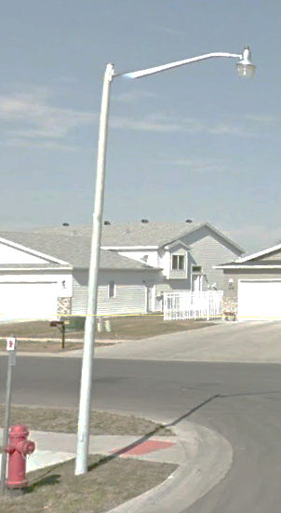
Fixture:
Manufacturer: Cooper
Model: Caretaker CRTK2
Pole:
Manufacturer: Shakespeare
30’ Composite With 6’ arm
Standard Decorative
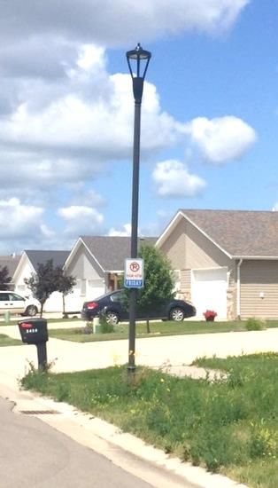
Fixture:
Manufacturer: Cyclone
Model: Concerto (fly thru) or
Meridian (acorn)
Pole:
Manufacturer: Cyclone
Model: PAC20 Aluminum

Public Street Light Placement and Spacing

Residential Areas

The base criteria governing installation before 2016 are as follows:

- One streetlight shall be installed at every street intersection.
- One streetlight shall be installed within 150 feet of the end of every dead-end street.
- One streetlight shall be installed on the radius of every cul-de-sac.
- Streetlights shall be installed near curves.
- Streetlights shall be a minimum of 300 feet apart and a maximum of 600 feet apart except as required to light intersections, curves, dead-end streets or cul-de-sacs. This distance may be modified to maintain an equidistant spacing of lighting fixtures and/or uniformity in illumination.

The base criteria governing installation after 2015:

- One streetlight shall be installed at every street intersection.
- One streetlight shall be installed within 75 feet of the end of every dead-end street.
- One streetlight shall be installed on the radius of every cul-de-sac.
- Streetlights shall be installed near curves.
- Streetlights shall be spaced as close to 300 feet apart as is practical, but no farther than 300 feet apart. This distance may be modified to maintain an equidistant spacing of lighting fixtures and/or uniformity in illumination.

The criteria governing the installation along streets within or adjacent to property zoned RLD-0 (Oakport Annexation Area) will be developed following a public input process and incorporated into the Street Light Standards at that time.

Commercial/Industrial Areas & Minor Arterial/Collector Streets

For commercial/industrial areas and along minor arterial/collector streets, MnDOT lighting standards shall be followed. The applicable standards can be found at:

www.dot.state.mn.us/trafficeng/lighting/manual.html

